Практическая работа 6
Тема: «Построение дерева решений»

Цель: научиться создавать и визуализировать дерево решений для анализа и принятия оптимальных управленческих решений в различных ситуациях.

Ход работы
- Дизайн
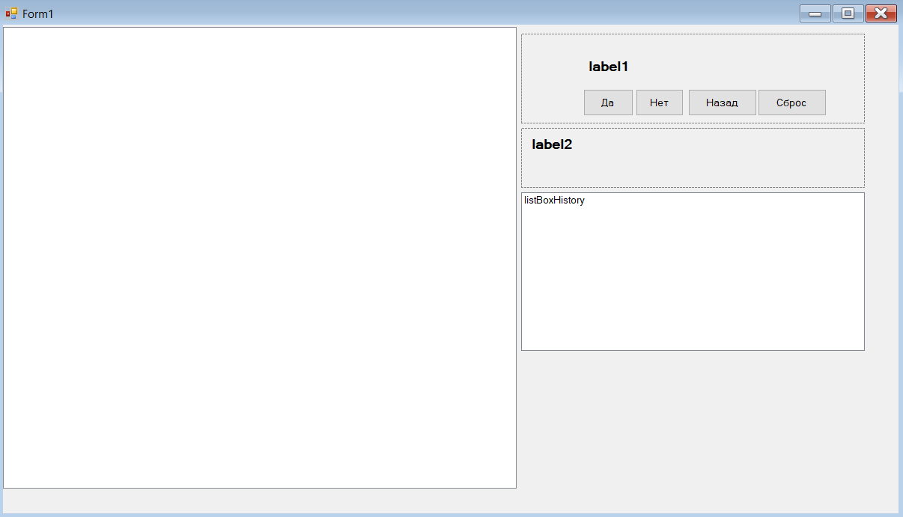
- Код
Form1
using System;
using System.Collections.Generic;
using System.Drawing;
using System.Windows.Forms;
using DecisionTreeApp.Models;
using DecisionTreeApp.Services;

namespace DecisionTreeApp
{
public partial class Form1 : Form
{
private DecisionTreeService _decisionService;
private TreeNode _treeRoot;

public Form1()
{
InitializeComponent();
InitializeService();
SetupForm();
LoadDecisionTree();
UpdateUI();
}

private void InitializeService()
{
_decisionService = new DecisionTreeService();

_decisionService.QuestionChanged += (s, q) =>
{
if (InvokeRequired)
Invoke(new Action(() => lblQuestion.Text = q));
else
lblQuestion.Text = q;
};

_decisionService.ResultReached += (s, r) =>
{
if (InvokeRequired)
{
Invoke(new Action(() =>
{
lblResult.Text = r;
btnYes.Enabled = false;
btnNo.Enabled = false;
}));
}
else
{
lblResult.Text = r;
btnYes.Enabled = false;
btnNo.Enabled = false;
}
};

_decisionService.HistoryUpdated += (s, history) =>
{
if (InvokeRequired)
Invoke(new Action(() => UpdateHistoryList(history)));
else
UpdateHistoryList(history);
};
}

private void UpdateHistoryList(List<HistoryItem> history)
{
listBoxHistory.Items.Clear();
foreach (var item in history)
{
listBoxHistory.Items.Add(item.ToString());
}

if (listBoxHistory.Items.Count > 0)
listBoxHistory.TopIndex = listBoxHistory.Items.Count - 1;
}

private void SetupForm()
{
this.Text = "Дерево решений: Запуск нового продукта";
this.Size = new Size(1000, 700);
this.StartPosition = FormStartPosition.CenterScreen;

btnYes.Click += BtnYes_Click;
btnNo.Click += BtnNo_Click;
btnBack.Click += BtnBack_Click;
btnReset.Click += BtnReset_Click;
}

private void LoadDecisionTree()
{
treeViewDecision.Nodes.Clear();
_treeRoot = _decisionService.GetTreeViewNodes();
treeViewDecision.Nodes.Add(_treeRoot);
treeViewDecision.ExpandAll();
}

private void UpdateUI()
{
lblQuestion.Text = _decisionService.GetCurrentQuestion();

if (_decisionService.IsResultReached())
{
lblResult.Text = _decisionService.GetCurrentResult();
btnYes.Enabled = false;
btnNo.Enabled = false;
}
else
{
lblResult.Text = "";
btnYes.Enabled = true;
btnNo.Enabled = true;
}

if (treeViewDecision.Nodes.Count > 0)
HighlightCurrentNode();
}

private void HighlightCurrentNode()
{
int currentNodeId = GetCurrentNodeId();
if (currentNodeId > 0)
_decisionService.HighlightCurrentNode(treeViewDecision.Nodes, currentNodeId);
}

private int GetCurrentNodeId()
{
string currentQuestion = _decisionService.GetCurrentQuestion();
return FindNodeIdByText(treeViewDecision.Nodes, currentQuestion);
}

private int FindNodeIdByText(TreeNodeCollection nodes, string text)
{
foreach (TreeNode node in nodes)
{
if (node.Text.Contains(text) && node.Tag != null)
return (int)node.Tag;

if (node.Nodes.Count > 0)
{
int result = FindNodeIdByText(node.Nodes, text);
if (result > 0) return result;
}
}
return -1;
}

private void BtnYes_Click(object sender, EventArgs e)
{
_decisionService.AnswerYes();
UpdateUI();
}

private void BtnNo_Click(object sender, EventArgs e)
{
_decisionService.AnswerNo();
UpdateUI();
}

private void BtnBack_Click(object sender, EventArgs e)
{
if (!_decisionService.GoBack())
MessageBox.Show("Вы уже в начале дерева решений", "Информация",
MessageBoxButtons.OK, MessageBoxIcon.Information);
UpdateUI();
}

private void BtnReset_Click(object sender, EventArgs e)
{
_decisionService.ResetToRoot();
listBoxHistory.Items.Clear();
UpdateUI();
btnYes.Enabled = true;
btnNo.Enabled = true;
}
}
}
Models.cs
using System;
using System.Collections.Generic;

namespace DecisionTreeApp.Models
{
public class DecisionNode
{
public int Id { get; set; }
public string Text { get; set; }
public DecisionNode YesNode { get; set; }
public DecisionNode NoNode { get; set; }
public bool IsLeaf { get; set; }
public string Result { get; set; }

public DecisionNode(int id, string text)
{
Id = id;
Text = text;
IsLeaf = false;
}

public DecisionNode(int id, string text, string result)
{
Id = id;
Text = text;
Result = result;
IsLeaf = true;
}
}

public class HistoryItem
{
public int NodeId { get; set; }
public string Question { get; set; }
public string Answer { get; set; }
public DateTime Time { get; set; }

public override string ToString()
{
return $"Вопрос: {Question} → Ответ: {Answer}";
}
}
}
Services.cs
using DecisionTreeApp.Models;
using System;
using System.Collections.Generic;
using System.Drawing;
using System.Windows.Forms;

namespace DecisionTreeApp.Services
{
public class DecisionTreeService
{
private DecisionNode _rootNode;
private DecisionNode _currentNode;
private Stack<DecisionNode> _navigationHistory;
private List<HistoryItem> _answerHistory;

public event EventHandler<string> QuestionChanged;
public event EventHandler<string> ResultReached;
public event EventHandler<List<HistoryItem>> HistoryUpdated;

public DecisionTreeService()
{
_navigationHistory = new Stack<DecisionNode>();
_answerHistory = new List<HistoryItem>();
BuildDecisionTree();
ResetToRoot();
}

private void BuildDecisionTree()
{
var resultLaunchNow = new DecisionNode(101, "Результат", "Запускать немедленно");
var resultNeedUSP = new DecisionNode(102, "Результат", "Нужно УТП (уникальное торговое предложение)");
var resultAnalyzeCompetitors = new DecisionNode(103, "Результат", "Анализировать конкурентов");
var resultFindNiche = new DecisionNode(104, "Результат", "Искать нишу");
var resultLaunchCarefully = new DecisionNode(105, "Результат", "Запускать с осторожностью");
var resultOptimizeProduction = new DecisionNode(106, "Результат", "Оптимизировать производство");
var resultFindInvestors = new DecisionNode(107, "Результат", "Искать инвесторов");
var resultReviseBusinessPlan = new DecisionNode(108, "Результат", "Пересмотреть бизнес-план");
var resultPrepareLaunch = new DecisionNode(109, "Результат", "Готовиться к запуску");
var resultPostponeLaunch = new DecisionNode(110, "Результат", "Отложить запуск");
var resultDevelopOffSeason = new DecisionNode(111, "Результат", "Развивать в низкий сезон");
var resultFindOtherMarket = new DecisionNode(112, "Результат", "Искать другой рынок");
var resultAbandon = new DecisionNode(113, "Результат", "Отказаться от запуска");

var nodeLowSeason = new DecisionNode(506, "Пик спроса не скоро?");
nodeLowSeason.YesNode = resultDevelopOffSeason;
nodeLowSeason.NoNode = resultFindOtherMarket;

var nodePeakSoon = new DecisionNode(505, "Пик спроса скоро?");
nodePeakSoon.YesNode = resultPrepareLaunch;
nodePeakSoon.NoNode = resultPostponeLaunch;

var nodeHighCost = new DecisionNode(504, "Высокая себестоимость?");
nodeHighCost.YesNode = resultFindInvestors;
nodeHighCost.NoNode = resultReviseBusinessPlan;

var nodeLowCost = new DecisionNode(503, "Низкая себестоимость?");
nodeLowCost.YesNode = resultLaunchCarefully;
nodeLowCost.NoNode = resultOptimizeProduction;

var nodeHighCompetition = new DecisionNode(502, "Высокая конкуренция?");
nodeHighCompetition.YesNode = resultAnalyzeCompetitors;
nodeHighCompetition.NoNode = resultFindNiche;

var nodeLowCompetition = new DecisionNode(501, "Низкая конкуренция?");
nodeLowCompetition.YesNode = resultLaunchNow;
nodeLowCompetition.NoNode = resultNeedUSP;

var nodeSeasonality = new DecisionNode(404, "Есть сезонность?");
nodeSeasonality.YesNode = nodePeakSoon;
nodeSeasonality.NoNode = nodeLowSeason;

var nodeLowProfit = new DecisionNode(403, "Низкая прибыль?");
nodeLowProfit.YesNode = nodeLowCost;
nodeLowProfit.NoNode = nodeHighCost;

var nodeHighProfit = new DecisionNode(402, "Высокая прибыль?");
nodeHighProfit.YesNode = nodeLowCompetition;
nodeHighProfit.NoNode = nodeHighCompetition;

var nodeLowDemand = new DecisionNode(401, "Низкий спрос?");
nodeLowDemand.YesNode = nodeSeasonality;
nodeLowDemand.NoNode = resultAbandon;

var nodeHighDemand = new DecisionNode(301, "Высокий спрос?");
nodeHighDemand.YesNode = nodeHighProfit;
nodeHighDemand.NoNode = nodeLowProfit;

var root = new DecisionNode(1, "Запускать новый продукт?");
root.YesNode = nodeHighDemand;
root.NoNode = nodeLowDemand;

_rootNode = root;
}

public void ResetToRoot()
{
_currentNode = _rootNode;
_navigationHistory.Clear();
_answerHistory.Clear();
OnQuestionChanged(_currentNode.Text);
OnHistoryUpdated();
}

public void AnswerYes()
{
if (_currentNode == null || _currentNode.IsLeaf) return;

_answerHistory.Add(new HistoryItem
{
NodeId = _currentNode.Id,
Question = _currentNode.Text,
Answer = "Да",
Time = DateTime.Now
});

_navigationHistory.Push(_currentNode);
_currentNode = _currentNode.YesNode;

if (_currentNode != null)
{
if (_currentNode.IsLeaf)
OnResultReached(_currentNode.Result);
else
OnQuestionChanged(_currentNode.Text);
}

OnHistoryUpdated();
}

public void AnswerNo()
{
if (_currentNode == null || _currentNode.IsLeaf) return;

_answerHistory.Add(new HistoryItem
{
NodeId = _currentNode.Id,
Question = _currentNode.Text,
Answer = "Нет",
Time = DateTime.Now
});

_navigationHistory.Push(_currentNode);
_currentNode = _currentNode.NoNode;

if (_currentNode != null)
{
if (_currentNode.IsLeaf)
OnResultReached(_currentNode.Result);
else
OnQuestionChanged(_currentNode.Text);
}

OnHistoryUpdated();
}

public bool GoBack()
{
if (_navigationHistory.Count > 0)
{
_currentNode = _navigationHistory.Pop();
if (_answerHistory.Count > 0)
_answerHistory.RemoveAt(_answerHistory.Count - 1);

OnQuestionChanged(_currentNode.Text);
OnHistoryUpdated();
return true;
}
return false;
}

public string GetCurrentQuestion() => _currentNode?.Text ?? "Дерево решений не инициализировано";
public bool IsResultReached() => _currentNode != null && _currentNode.IsLeaf;
public string GetCurrentResult() => _currentNode?.Result ?? "";
public List<HistoryItem> GetHistory() => _answerHistory;

public TreeNode GetTreeViewNodes()
{
return BuildTreeNode(_rootNode);
}

private TreeNode BuildTreeNode(DecisionNode node)
{
if (node == null) return null;

var treeNode = new TreeNode(node.Text);
treeNode.Tag = node.Id;

if (node.IsLeaf)
{
treeNode.Text = node.Result;
}

if (node.YesNode != null)
{
var yesNode = BuildTreeNode(node.YesNode);
yesNode.Text = "Да → " + (yesNode.Text.Contains("Результат") ? "" : yesNode.Text);
treeNode.Nodes.Add(yesNode);
}

if (node.NoNode != null)
{
var noNode = BuildTreeNode(node.NoNode);
noNode.Text = "Нет → " + (noNode.Text.Contains("Результат") ? "" : noNode.Text);
treeNode.Nodes.Add(noNode);
}

return treeNode;
}

public void HighlightCurrentNode(TreeNodeCollection nodes, int currentNodeId)
{
foreach (TreeNode node in nodes)
{
if (node.Tag != null && (int)node.Tag == currentNodeId)
{
node.BackColor = SystemColors.Highlight;
node.ForeColor = SystemColors.HighlightText;
}
else
{
node.BackColor = SystemColors.Window;
node.ForeColor = SystemColors.WindowText;
}

if (node.Nodes.Count > 0)
HighlightCurrentNode(node.Nodes, currentNodeId);
}
}

protected virtual void OnQuestionChanged(string question) => QuestionChanged?.Invoke(this, question);
protected virtual void OnResultReached(string result) => ResultReached?.Invoke(this, result);
protected virtual void OnHistoryUpdated() => HistoryUpdated?.Invoke(this, _answerHistory);
}
}
- Тестируем
